Networks
Week 6
Client Server
21BCE1889
Aditya Sai

TCP client :

import socket

host_ip, server_port = "127.0.0.1", 9999
data = input("Enter data to be sent: ")
tcp_client = socket.socket(socket.AF_INET, socket.SOCK_STREAM)

try:
tcp_client.connect((host_ip, server_port))
tcp_client.sendall(data.encode())
received = tcp_client.recv(1024)
finally:
tcp_client.close()

print("Sent: {}".format(data))
print("Received: {}".format(received.decode()))

TCP server:

import socketserver

class Handler_TCPServer(socketserver.BaseRequestHandler):
def handle(self):
self.data = self.request.recv(1024).strip()
print("{} sent:".format(self.client_address[0]))
print(self.data)
self.request.sendall("ACK from TCP Server".encode())

if __name__ == "__main__":
HOST, PORT = "localhost", 9999
tcp_server = socketserver.TCPServer((HOST, PORT), Handler_TCPServer)
tcp_server.serve_forever()
# To abort the TCP server, press Ctrl-C.
tcp_server.serve_forever()

O/P :
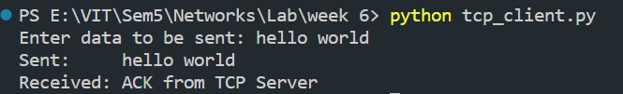

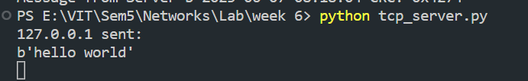

UDP Client :

import socket
import datetime

now = datetime.datetime.now()

msgFromClient = now.strftime("%Y-%m-%d %H:%M:%S")
bytesToSend = str.encode(msgFromClient)
serverAddressPort = ("127.0.0.1", 20001)
bufferSize = 1024

UDPClientSocket = socket.socket(family=socket.AF_INET, type=socket.SOCK_DGRAM)
UDPClientSocket.sendto(bytesToSend, serverAddressPort)
msgFromServer = UDPClientSocket.recvfrom(bufferSize)
msg = "Message from Server {}".format(msgFromServer[0])

print(msg)

UDP Server :

import socket
import datetime

localIP = "127.0.0.1"
localPort = 20001
bufferSize = 1024

now = datetime.datetime.now()

msgFromServer = now.strftime("%Y-%m-%d %H:%M:%S")
bytesToSend = str.encode(msgFromServer)

UDPServerSocket = socket.socket(family=socket.AF_INET, type=socket.SOCK_DGRAM)
UDPServerSocket.bind((localIP, localPort))
print("UDP server up and listening")
while True:
bytesAddressPair = UDPServerSocket.recvfrom(bufferSize)
message = bytesAddressPair[0]
address = bytesAddressPair[1]
clientMsg = "Message from Client:{}".format(message)
clientIP = "Client IP Address:{}".format(address)
print(clientMsg)
print(clientIP)
UDPServerSocket.sendto(bytesToSend, address)

O/P :

